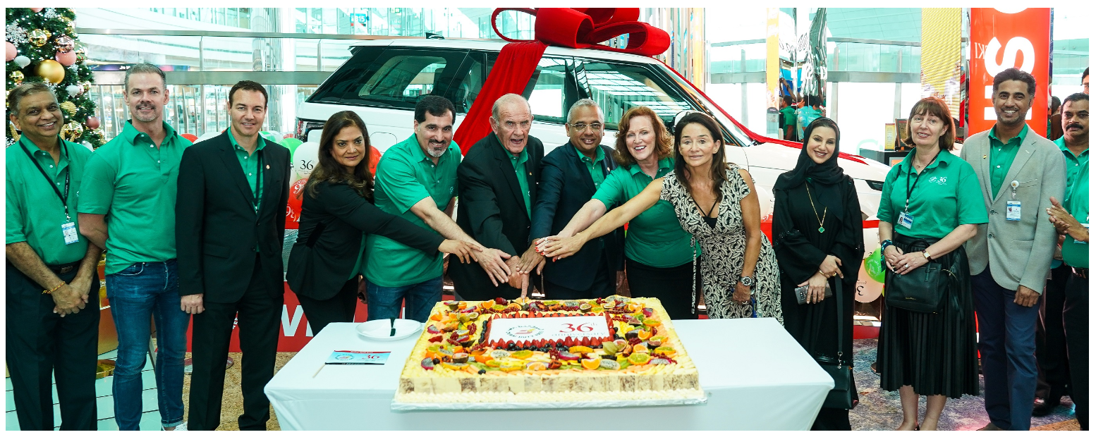

Founded in 1983, Dubai Duty Free recorded first-year sales of US$20 million and has grown into one of the biggest travel retail operator in the world.

2019 was another record year for Dubai Duty Free which celebrated its 36th anniversary on December 20th and crossed the US$2 billion mark on 26th December, and year-end sales reached US$2.029 billion.

Dubai Duty Free currently operates over 34,600sqm of retail space at Dubai International Airport and 4,658sqm at Al Maktoum International that will grow in line with the massive development plans of Dubai South.

Now employing almost 6,100 people, the operation has consistently raised the benchmark for airport retailing and it continues to grow. Of the original 100 staff who joined in 1983, 24 are still in active service and referred to as “Pioneers”.

---------------------------------------------------------------------------------------------

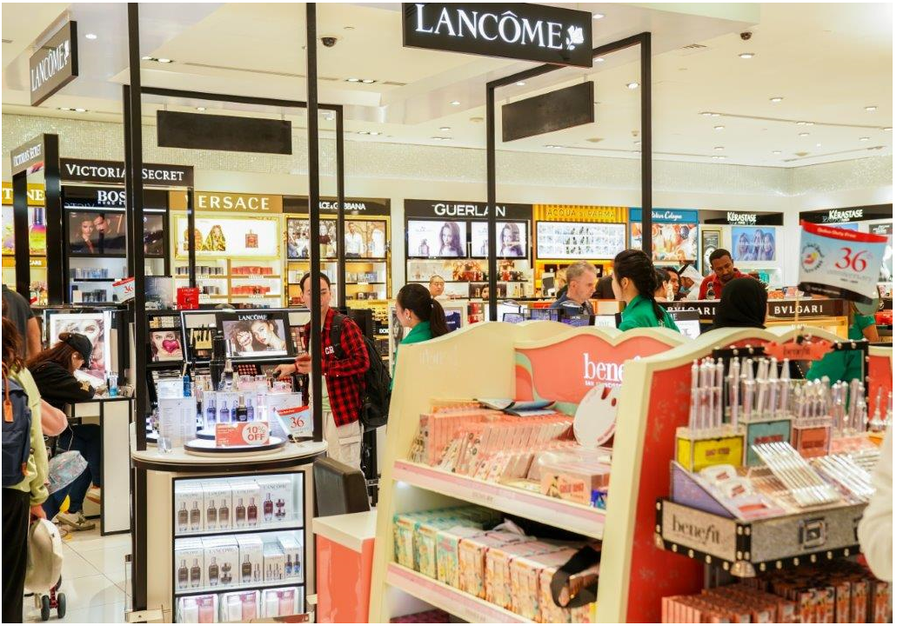

**A GLOBAL LEADER**

Since its opening in December 1983, Dubai Duty Free has grown into one of the biggest travel retail operators in the world.

Founded in 1983, Dubai Duty Free recorded first-year sales of US$20 million and has grown into one of the biggest travel retail operators in the world with sales turnover of US$2.029 billion in 2019.

Now employing almost 6,100 people, the operation has consistently raised the benchmark for airport retailing and it continues to grow.

Dubai Duty Free currently operates over 34,600sqm of retail space at Dubai International Airport and 4,658sqm at Al Maktoum International.

In addition to its retail operation, Dubai Duty Free operates a Leisure Division which includes The Irish Village in Garhoud, Riverland Dubai and Studio One hotel at Dubai Studio City, The Century Village, Dubai Duty Free Tennis Stadium and The Jumeirah Creekside Hotel.

While the successful running of the shopfloor is a major focus for Dubai Duty Free, the operation is highly committed to promoting Dubai through a series of high level sporting events including the Dubai Duty Free Tennis Championships, Dubai Duty Free Irish Open and Dubai Duty Free Irish Derby to name a few. To date, Dubai Duty Free has received over 700 awards including the Frontier Award for 'Airport Retailer of the Year', which was won by the operation for a remarkable ninth time.

Dubai Duty Free's Executive Vice Chairman and CEO, Colm McLoughlin was also presented with several awards including the "Irish Presidential Distinguished Service Award" in 2014 and the "Lifetime Achievement Award" at the Asian Business Leadership Forum (ABLF) in 2019.

In June 2019, Mr McLoughlin was honoured by Kildare County Council for his contribution to Co.Kildare through Dubai Duty Free's sponsorship of the Dubai Duty Free Irish Derby at the Curragh Racecourse over the last 12 years and the Dubai Duty Free Irish Open which was held in The K Club in 2016.

Other awards presented to hm were the “Outstanding Contribution to the Aviation Industry", the "Lifetime Achievement Award" at the 8th ME Hospitality Awards, "Male Leader of the Year “ at the Middle East Economic Digest and The Moodie Report's "People of the Year".

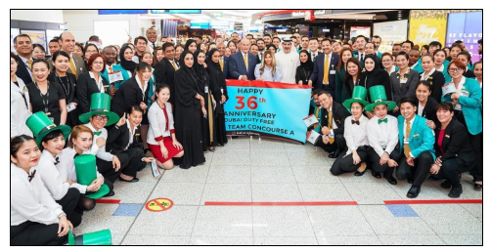

**Dubai Duty Free's 36th Anniversary**

Dubai Duty Free marked its 36th anniversary in style as it welcomed passengers travelling through Dubai with a special 25% discount on a wide range of merchandise over three days which began at midnight on 18th December and continued until the operation’s anniversary day on 20th December. Total sales for the three days reached Dhs209.48 million (US$57.39 million).

The anniversary discount for 72 hours resulted in a spending spree at Dubai International and at Al Maktoum International airports with sales figures on 18th December reaching Dhs49.83 million (US$13.65 million) and Dhs47.99 million (US$13.15 million) on 19th December.

On the anniversary day itself, 20th December, Dubai Duty Free daily sales reached Dhs111.65 million (US$30.59 million)

From a category point of view, Cosmetics was the highest selling category with sales of Dhs54.80 million (US$15.02 million) during the three-day period followed by Perfumes with sales of Dhs37.55 million (US$ 10.29 million) and Watches with Dhs33.35 million (US$9.14 million) sales.

**Recent and Future Developments**

In addition to its record annual sales, Dubai Duty Free has continued to develop its retail offer in all the terminals and that included the opening of a Chanel boutique, a Maison Christian Dior shop and a Gucci boutique. The operation is also looking forward to the opening of the new 1,100sqm retail space in Terminal 3 Arrivals this January. The new arrivals shop is much more visible to passengers in the baggage area and has a fantastic Liquor retail offer.

Dubai Duty Free will also continue the second phase of the refurbishment of the two FoodPlus shops in Concourse B and will continue to enhance its retail offer within the Fashion category in the second half of 2020.